Anush Sriram Ramesh

Mobile Robotics EECE 5550 Sec 01

HW 3

TSP and Graph search

**Question 1.**

**Question 2. *Python***

**2. A. i)**

Recover path function implementation: Function that takes in the pred map (implemented as a dictionary), reconstructs, and returns the Astar path found.

#Recover path from start to goal using predecessor dictionary

#start : start point of the path

#goal : goal point of the path

#pred : predecessor dictionary returned from astar search function

def RecoverPath(self, start, goal, pred):

current = goal

retracedPath = []

retracedPath.append(goal)

totalCost = 0

#print("pred = ", pred)

while current in pred:

#print("current = ", current)

prevPath = pred[current]

retracedPath.append(prevPath)

current = prevPath

if current == start:

break

if current != start:

print("no path found")

for i in range(len(retracedPath) - 1):

totalCost = totalCost + distance(retracedPath[i], retracedPath[i+1])

return retracedPath, totalCost

**2.A.ii)**

Astar search algorithm implemented as a member function of the class Astar which has the occupancy grid G, Distance function d, weight, and heuristics (w and h) function handles.

#Astar search algorithm

#graph : occupancy grid

#start : start point of the path

#goal : goal point of the path

#Function is implemented as a member function of the class AStar

def a_star(self):

while self.Q != []:

v = heapq.heappop(self.Q)[1]

del self.Qhelper[v]

if v == self.goal:

print("goal found")

return self.RecoverPath(self.start, self.goal, self.pred)

#print("neighbors of ", v, " = ", Neighbours(self.graph, v))

for n in Neighbours(self.graph,v):

#print("n = ", n)

pvi = self.costTo[v] + distance(v, n)

if pvi < self.costTo[n]:

#The path to i through v is better than the previously-known best path to i,

# so record it as the new best path to i.

self.pred[n] = v

self.costTo[n] = pvi

self.estTotalCost[n] = pvi + distance(n, self.goal)

if n in self.Qhelper:

tmpVal = self.Qhelper[n]

self.Q.remove((tmpVal, n ))

heapq.heappush(self.Q, (self.estTotalCost[n], n))

self.Qhelper[n] = self.estTotalCost[n]

else:

heapq.heappush(self.Q, (self.estTotalCost[n], n))

self.Qhelper[n] = self.estTotalCost[n]

return []

**2.B.i)**

N(v) : Neighbours function implemented as a global function that takes in occupancy grid as graph and the current vertex V and returns all the free neighbors of the vertex.

#Neighbour function : takes in occupancy grid and current vertex as input and return

the list of neighbors of #the current vertex as a list of tuples. [(N1),(n2),(n3),...]

#graph : occupancy grid

#v : current vertex

def Neighbours(graph, v):

neighbors = []

for x,y in neighbor_map:

search_point = (v[0]+x,v[1]+y)

if graph[search_point] == 1:

neighbors.append(search_point)

return neighbors

**2.B.ii)**

d(v1, v2) : Distance between two vertices function implemented as global function that takes in two vertices and returns the Euclidean distance between the vertices.

#distance(v1,v2) : returns the distance between two vertices v1 and v2

#v1 : vertex 1

#v2 : vertex 2

def distance(v1, v2):

return math.dist(v1, v2)

**2.B.iii)**

Using the functions implemented above, Astar search is performed between Start (635,140) and Goal (350,400). The path is plotted using matplotlib superimposed on the thresholded occupancy grid map given.

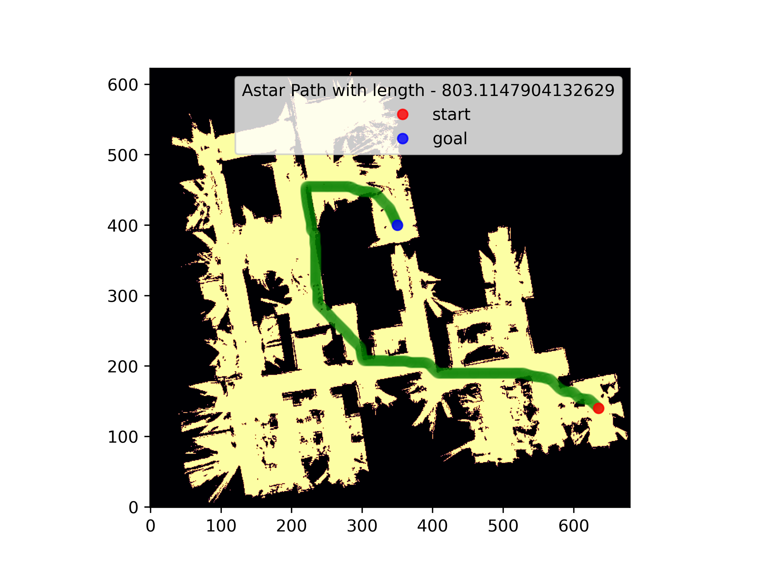Note: Ignore the slight overlap of the edge of the path over occupied cells as it is the thickness of the line to make it legible causing this, and the actual path doesn’t run over any blocked cells.

**Fig:** Astar Path calculated by the above implementation and path plotted with matplotlib. Total length of the path is 803.114

**2.C.i)**

Rejection Samples function – implemented as a global function that takes in a 2D numpy array – the occupancy grid and returns one sampled vertex from the free space.

#rejectionSamples(occupancyGrid) : returns a uniformly randomly sampled point from

the free space in the occupancy grid

#occupancyGrid : 2D NumPy array of the occupancy grid

#Returns : a tuple of the form (x,y) where x and y are the coordinates of the sampled point

def rejectionSampler(occupancyGrid):

while True:

x = int(np.random.uniform(0, occupancyGrid.shape[0]))

y = int(np.random.uniform(0, occupancyGrid.shape[1]))

if occupancyGrid[x][y] > 0:

return (x,y)

else:

continue

**2.C.ii)**

Reachability check : implemented as a global function taking in input as occupancy grid, point 1 and point2 and returns True if there is a line of sight between the 2 points, False otherwise.

#reachabilityCheck(occupancyGrid, point1, point2) : checks if there is a line of

sight between point1 and point2

#occupancyGrid : 2D NumPy array of the occupancy grid

#point1 : tuple of the form (x,y) where x and y are the coordinates of the first point

#point2 : tuple of the form (x,y) where x and y are the coordinates of the second point

#Returns : True if there is a line of sight between point1 and point2, False otherwise

def reachabilityCheck(occupancyGrid, v1, v2):

# print("v1: ", v1)

# print("v2: ", v2)

current = v1

while current != v2:

neighbors = Neighbours(occupancyGrid, current)

current = min(neighbors, key=lambda x: math.dist(x, v2))

if occupancyGrid[current] == 0:

return False

else:

continue

return True

**2.C.iii)**

Build PRM Graph : Implemented as a member function that accepts the number of samples to be generated as input and builds the graph as a member variable of the class PRM.

#build_graph() : builds the PRM graph using the rejection sampling algorithm for the

given number of samples and maximum distance

#number_of_samples : number of samples to be generated

#max_distance : maximum distance between two nodes in the graph

#returns : None

#Updates the graph, vertices, and edges attributes of the class PRM

def build_graph(self, n):

for i in range(n):

sampleVertex = rejectionSampler(self.occupancy_grid)

self.addVertex(sampleVertex, i)

#addVertex(vertex, index) : adds a vertex to the graph

#vertex : tuple of the form (x,y) where x and y are the coordinates of the vertex to be added sampled from the free space

#itr : index of the vertex to be added

#returns : None

def addVertex(self, sampleVertex, itr):

self.graph.add_node(itr, pos=sampleVertex)

if itr > 1:

for v in self.graph.nodes:

if (self.graph.nodes[v]['pos'] != sampleVertex) and (math.dist(self.graph.nodes[v]['pos'], sampleVertex) <= self.maxDistance):

if (reachablity_check(self.occupancy_grid, self.graph.nodes[v]['pos'], sampleVertex)):

self.graph.add_edge(v,itr, weight=math.dist(sampleVertex, self.graph.nodes[v]['pos']))

self.vertices.append(sampleVertex)

else:

continue

else:

continue

return

else:

return

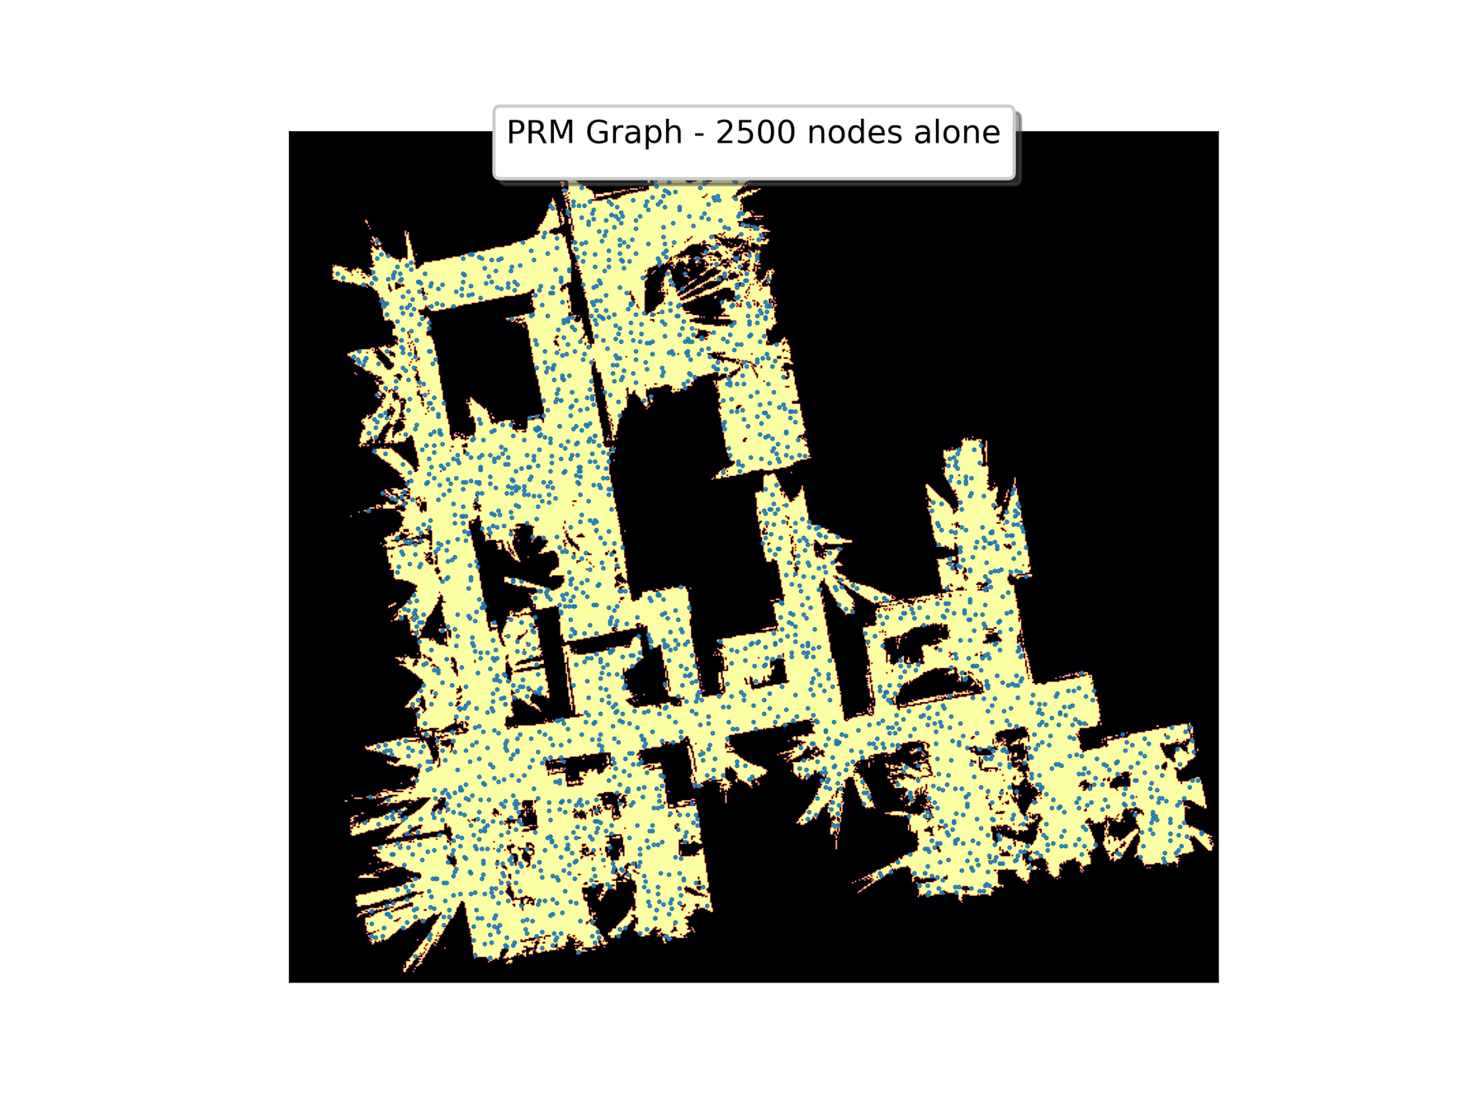**2.C.iv)**

**Fig:** 2500 nodes sampled from free space in occupancy grid and added to graph. Plotted with Matplotlib.

PRM Graph generated for 2500 samples generated using rejection sampling. Maximum distance between two nodes is 75.

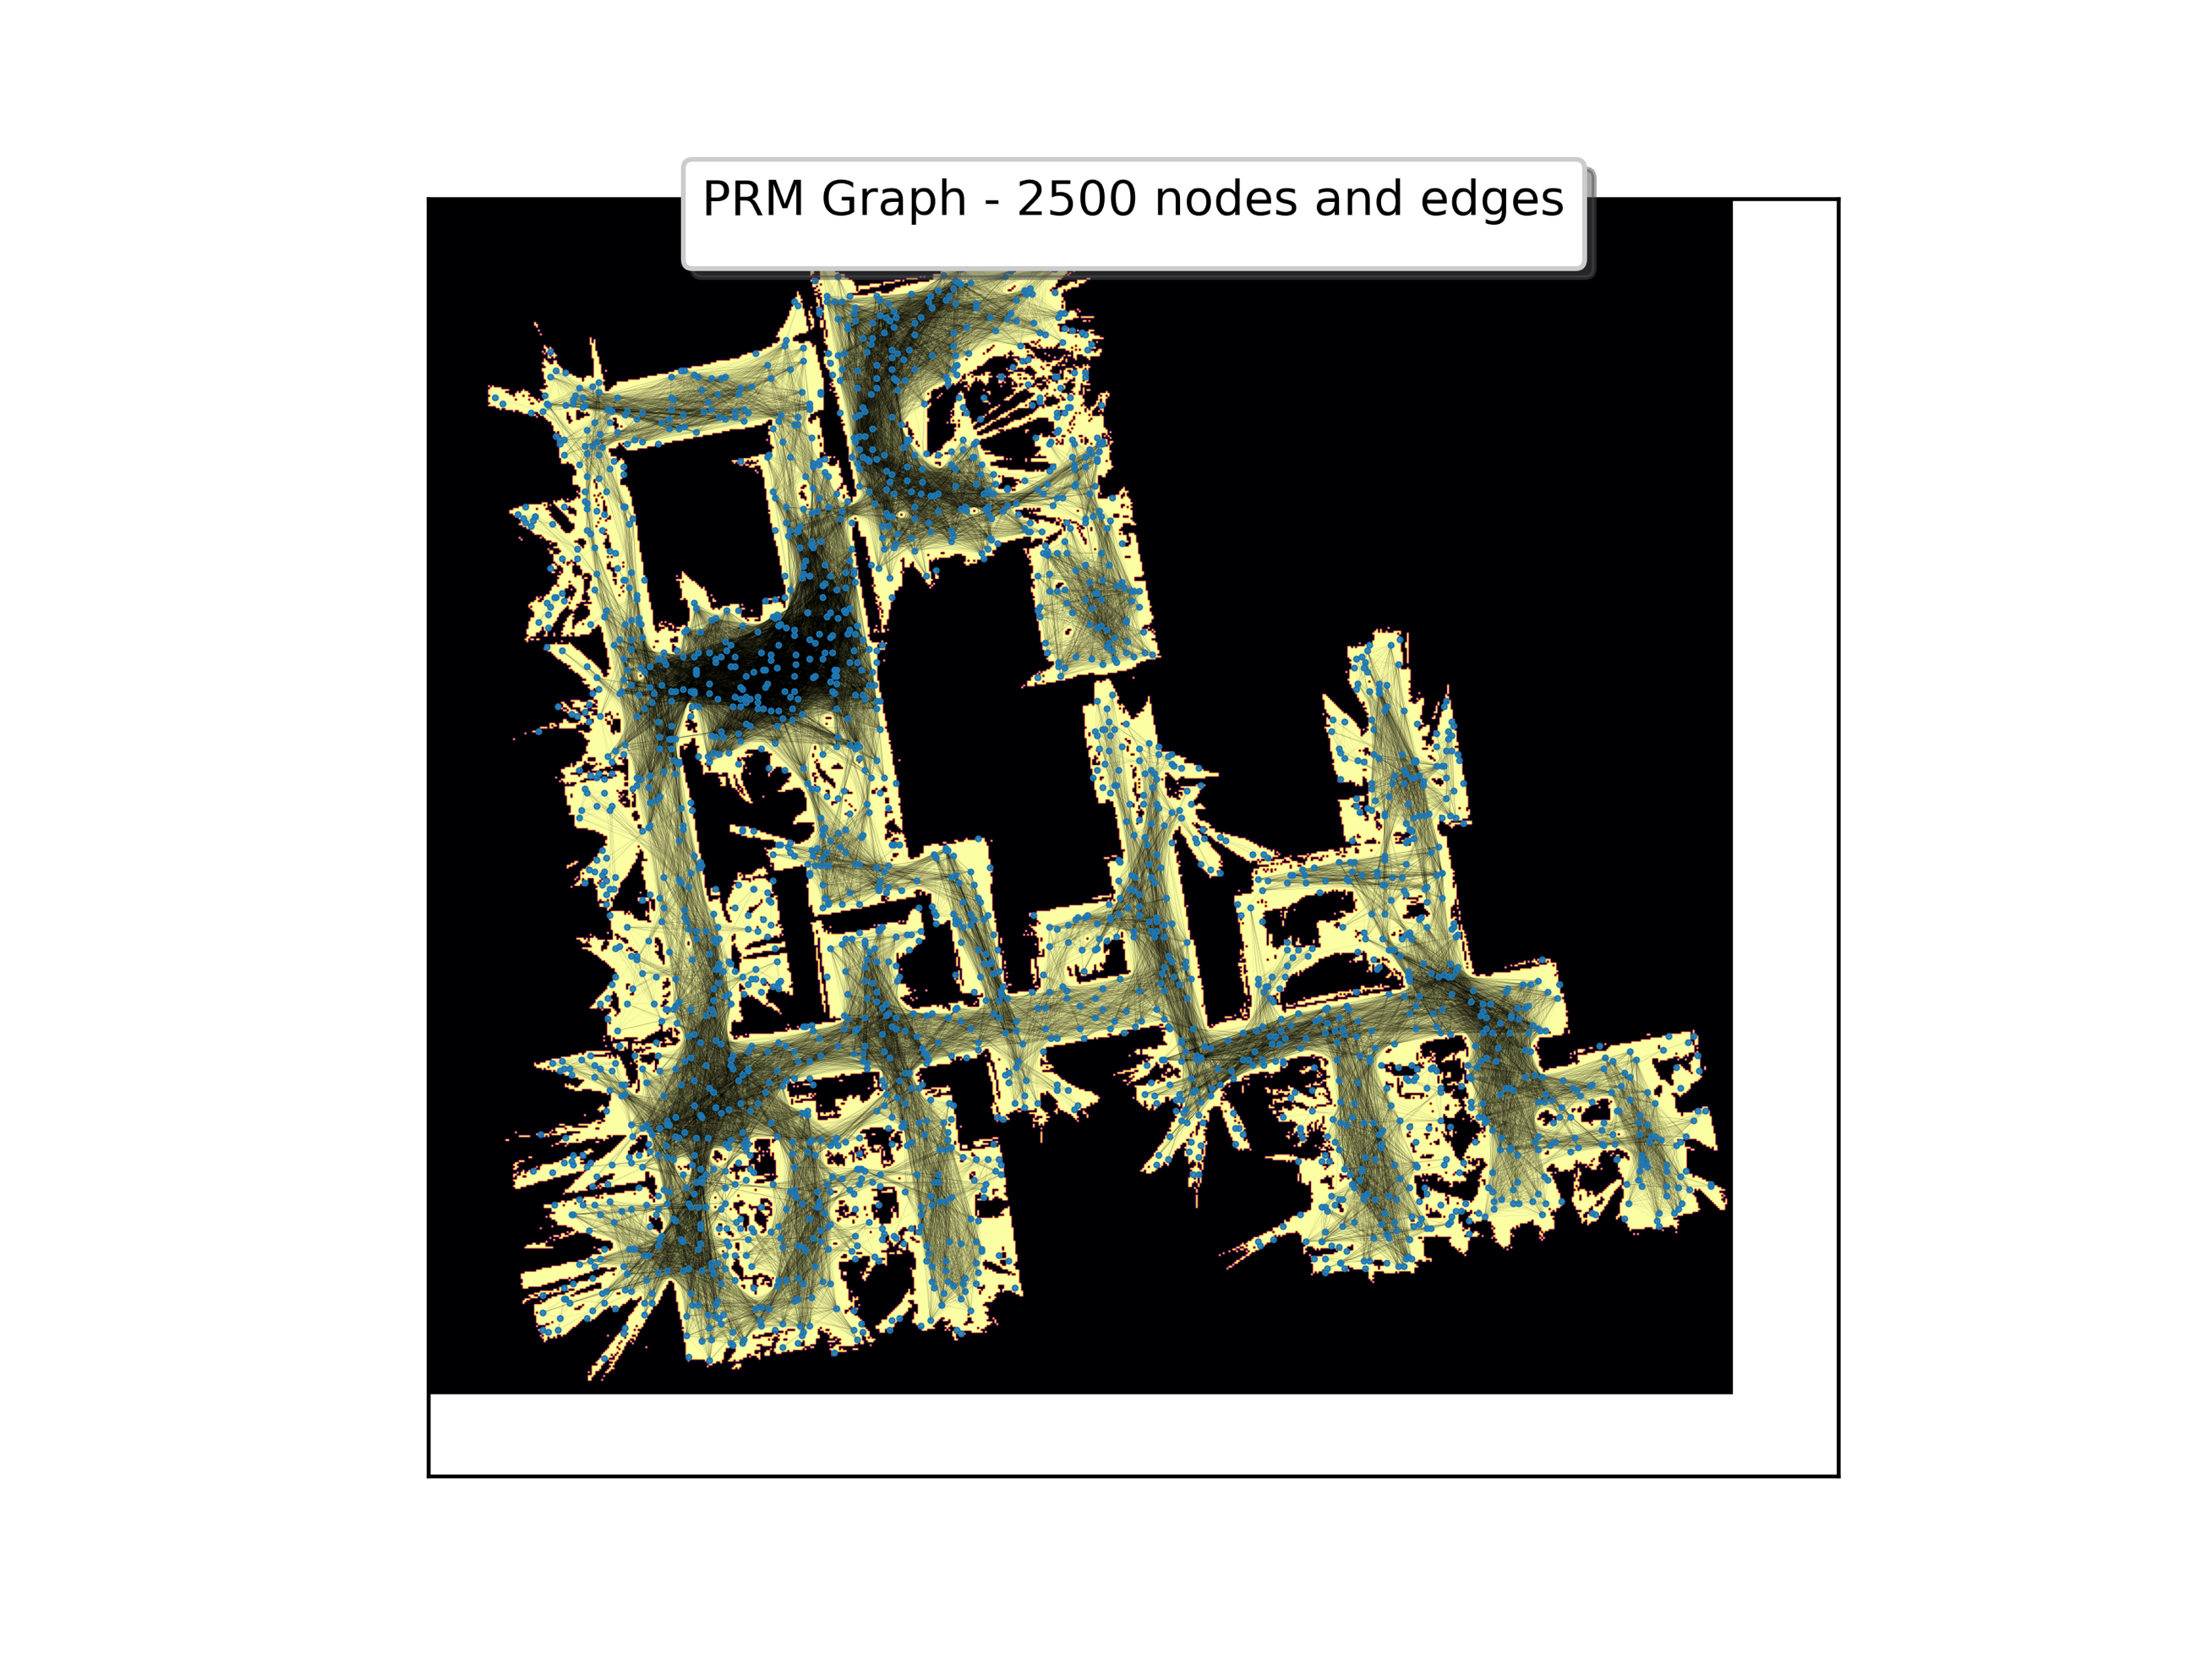

**Fig:** ValidEdges added to the nodes sampled using the reachability check function implemented above.

**2.C.v)**

Astar search performed on the graph generated above between 2 points, **Start (635,140)** and **Goal (350,400)**. The path is plotted with matplotlib with the edges in the graph removed for better visibility of the path.

**Fig:** Astar path found by the networkx’s astar_search function call and plotted. Total length of the path is 819.100